ThinkScripts

DISCLAIMER: These are provided, without warranty, or guarantee of accuracy. You’re responsible for your own trading decisions.

Step 1
Open Thinkorswim, Go to Charts, Click 'Studies' then Click 'Edit Studies'
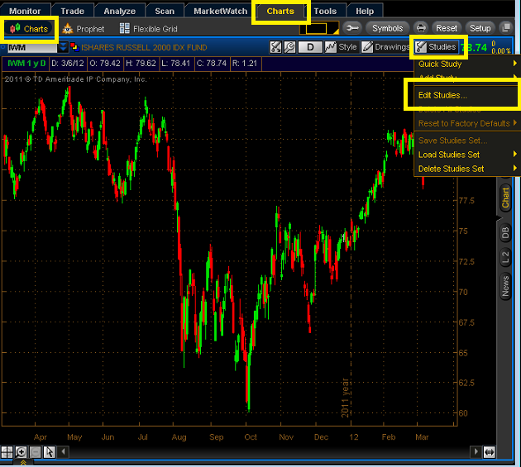

Step 2
In the Edit Studies and Strategies Menu, Click 'Import'
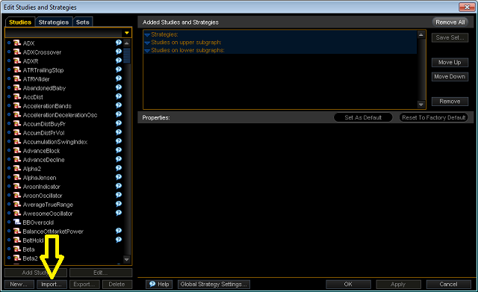

Step 3
In the 'Load Studies' mentu, navigate to the folder that has the study, then select the study and click 'Open'
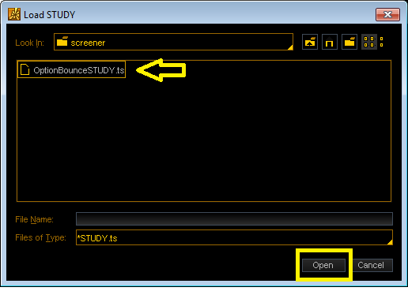

Step 4
The script is now imported into Thinkorswim, but you now must add it to your chart. To do this, in the 'Edit Studies and Strategies' menu, navigate to OptionBouncev1 in the 'studies' submenu. Highlight it, then click 'add study.'
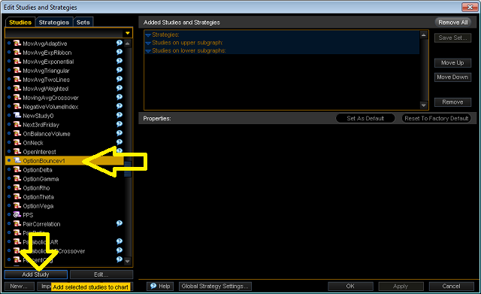

Step 5
Once the script has been made active, click 'Apply' then 'OK'
